Complete dashboard pictures
Individual Visualization Pictures
Project Over View
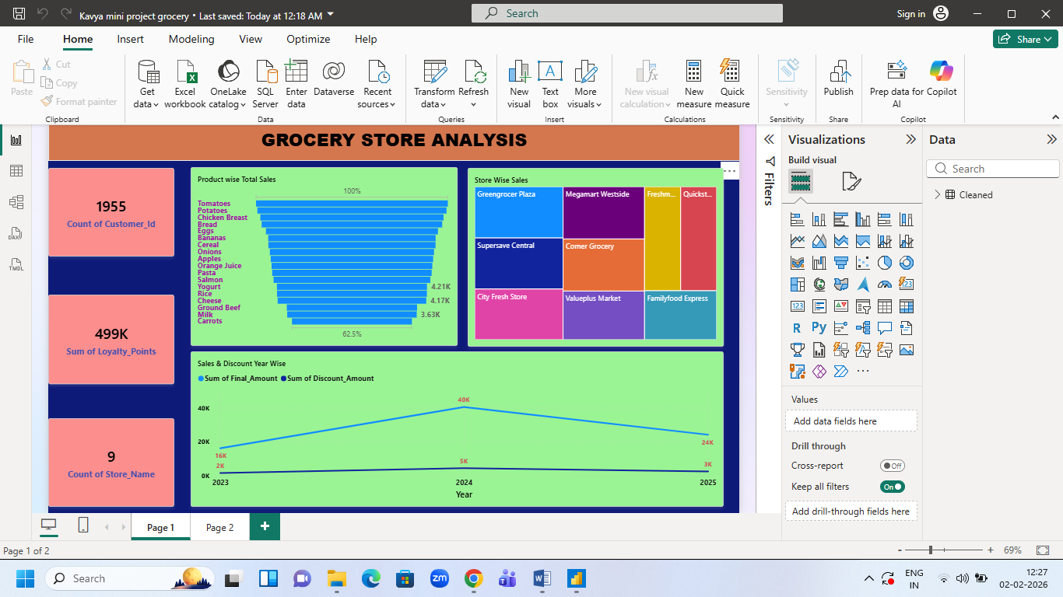
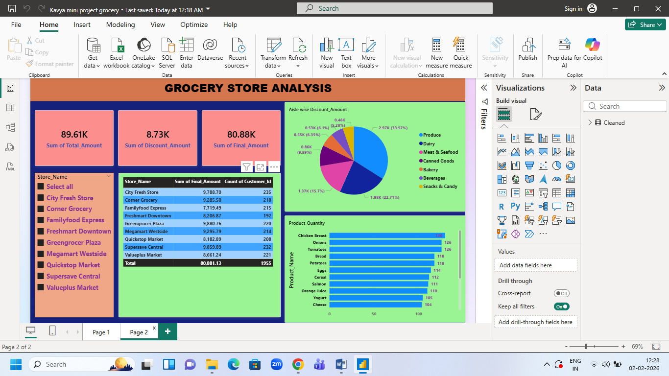
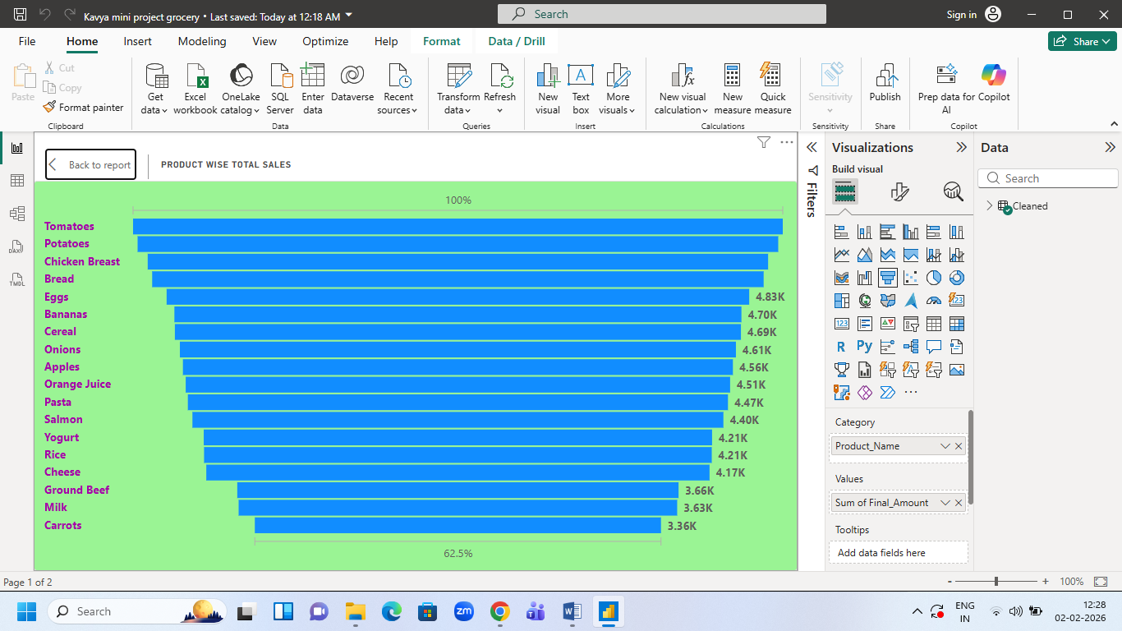
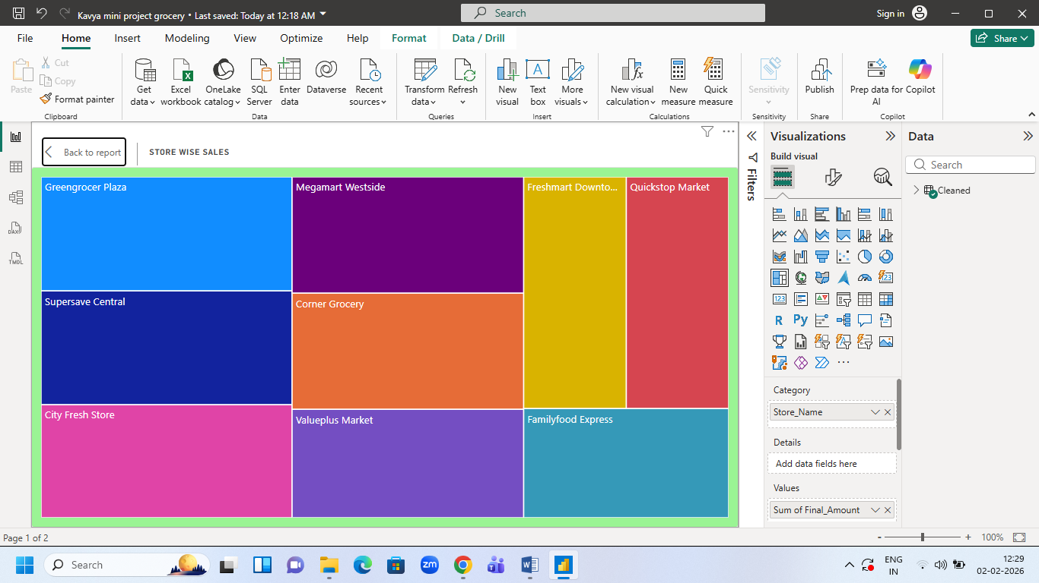
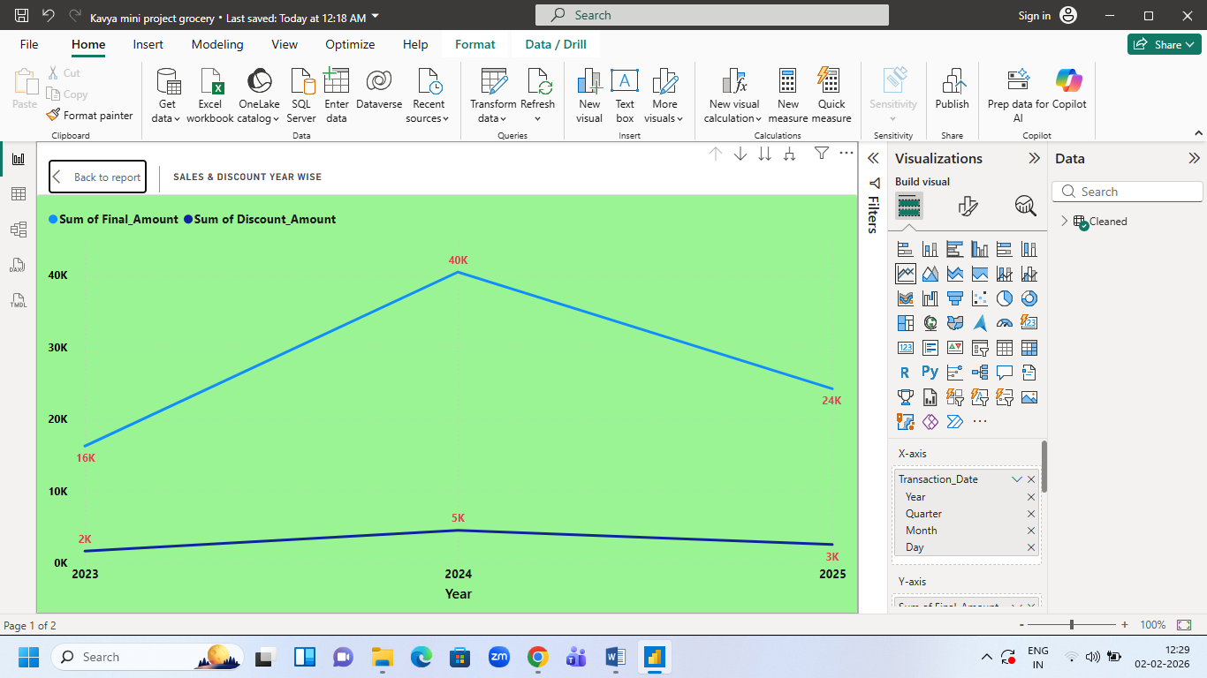
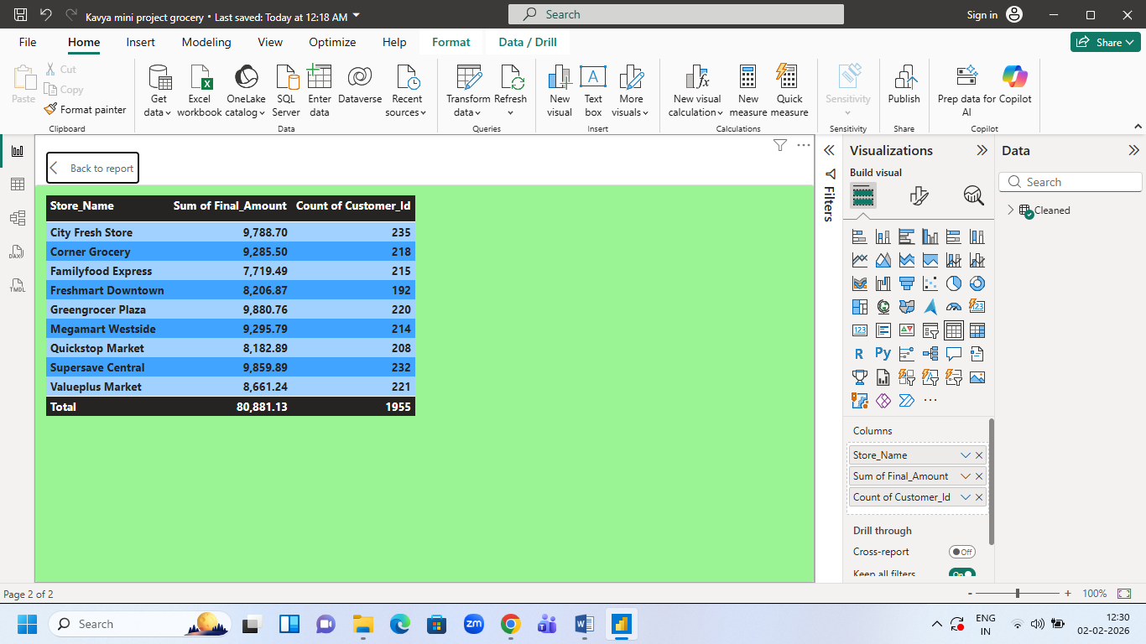
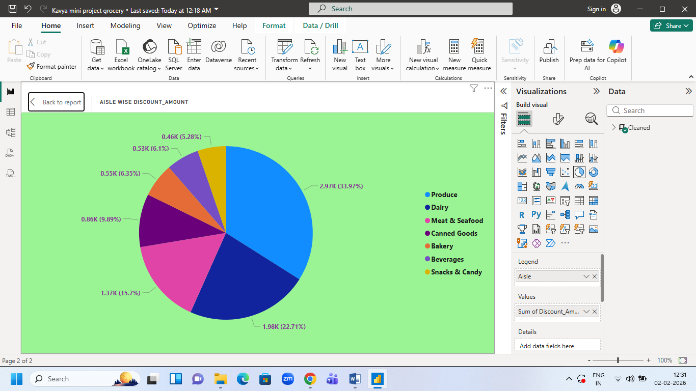
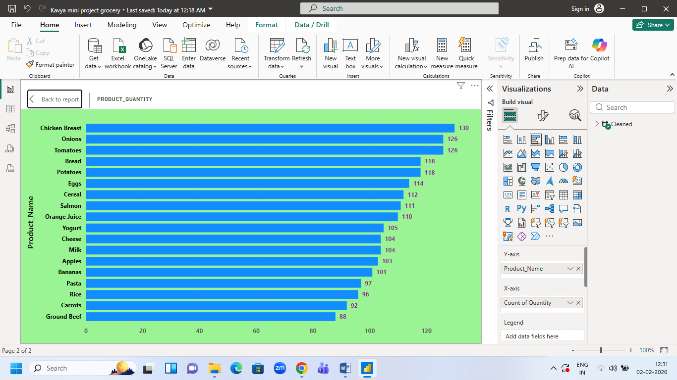

🛒 Grocery Sales & Performance Analysis using Power BI

📌 Executive Summary
This project focuses on analyzing grocery retail transaction data to gain insights into sales performance, product contribution, store efficiency, and customer loyalty behavior. Using a structured data cleaning approach and interactive Power BI dashboards, the project transforms raw transactional data into meaningful, decision-ready insights that can support business and operational decision-making.

❓ Problem Statement
Retail grocery businesses generate large volumes of transactional data, but raw data often contains inconsistencies such as incorrect date formats, negative revenue values due to discounts, missing values, and inconsistent naming conventions. Without proper data validation and visualization, these issues can lead to inaccurate reporting and poor business decisions.

📖 Background
Grocery retailers rely on accurate sales, product, and customer data to optimize inventory, pricing strategies, and promotional effectiveness. However, transactional datasets typically require significant preprocessing before analysis. This project simulates a real-world retail analytics scenario where raw data must be cleaned, validated, and visualized to extract reliable business insights.

🎯 Project Objectives
The primary objectives of this project are:
- To clean and validate raw grocery transaction data
- To standardize financial, date, and categorical fields
- To analyze sales trends and discount impact
- To evaluate product and aisle-level performance
- To assess store-wise sales contribution
- To understand customer loyalty and purchasing behavior
- To present insights through interactive Power BI dashboards

📊 Scope of the Project
This project covers:
- Grocery transaction sales analysis
- Product and aisle-level performance evaluation
- Store-wise revenue and sales trends
- Discount impact on final sales
- Customer loyalty points analysis
The project does not include forecasting or predictive modeling and focuses on descriptive and diagnostic analytics.

🗂️ Data Sources
- Raw Dataset: Grocery retail transaction data containing customer purchases, product details, pricing, discounts, and loyalty points.
- Cleaned Dataset: An Excel file created after validating and standardizing the raw data for analysis.

🧹 Data Cleaning & Preparation
Data preparation was performed in two stages:

1. Excel (Data Cleaning Layer)
- Corrected negative final sales values caused by excessive discounts
- Standardized date formats for time-based analysis
- Normalized store names, product names, and categories
- Ensured numerical columns were free from text and inconsistencies
- Preserved all records without deleting rows

2. Power BI (Reporting Layer)
- Handled blank and null values contextually using Power Query and DAX
- Applied business logic based on reporting requirements
- Prepared the data model for accurate KPI calculation and visualization

🔍 Methodology
- Imported raw transactional data
- Performed data validation and cleaning in Excel
- Loaded the cleaned dataset into Power BI
- Handled missing values and applied transformations in Power BI
- Created calculated measures and KPIs
- Designed interactive dashboards for business insights
- Analyzed trends and summarized key findings

🛠️ Tools & Technologies
- Microsoft Excel – Data cleaning and preprocessing
- Power BI – Data modeling, DAX calculations, and dashboard creation

📈 Key Dashboards & Insights
The Power BI dashboards provide insights into:
- Overall sales and net sales performance
- Discount impact on revenue
- Product and aisle-wise contribution
- Store-level sales trends
- Customer loyalty points and engagement
The dashboards are interactive, allowing users to filter and explore data dynamically.

✅ Expected Outcomes
- Accurate and reliable sales reporting
- Clear understanding of product and store performance
- Visibility into discount effectiveness
- Improved insights into customer loyalty behavior
- Business-ready dashboards for decision-makers

⚠️ Limitations & Assumptions
- The dataset represents historical transaction data only
- Customer behavior analysis is limited to available transaction records
- Loyalty points are assumed to be directly related to purchase value

🏁 Conclusion
This project demonstrates a complete end-to-end data analytics workflow, starting from raw data validation to clean, interactive Power BI dashboards. By separating data cleaning and reporting responsibilities, the analysis ensures accuracy, flexibility, and business relevance. The final dashboards enable stakeholders to quickly understand sales performance, identify trends, and support informed decision-making in a retail grocery context.

